Introduction

Jenkins is powerful CI/CD tool and it's so simple to use. The functionality of Jenkins can be extended via the installation of several existing plugins in the Market; they are available to use for everyone.
I consider this is the simplest approach to satisfy the limited requirement of this task:

“Design and implement deployment system to deploy and start a single jar java app on a remote server””

Deployment Strategy using Jenkins
I will use the following tools:
  - GitHub: as our main source control management tool, where my source lives.
  - Maven, let's build our Java Application as a Maven project to be easily handled by Jenkins.
  - Jenkins: as my Continuous Integration and Delivery tool.
Note: In order to make our Jenkins job able to run as we desire, we need the following plugins installed in our Jenkins Server:
      - “Git Plugin”, to have a Git repository as our SCM.
      - “Maven Plugin”
      - “Deploy to container Plugin”, I frequently use this plugin to make real deployments to Tomcat Servers, in this case, since we don't need to deploy our Java standalone app to any WebApp server, we'll only deploy the .jar file to a server and execute it via “SSH publisher” post-build action.
  - Ubuntu VMs (AWS): I have 3 virtual machines (Dev, Staging, Prod) with Ubuntu installed and all those already have JRE installed.

Deployment Diagram
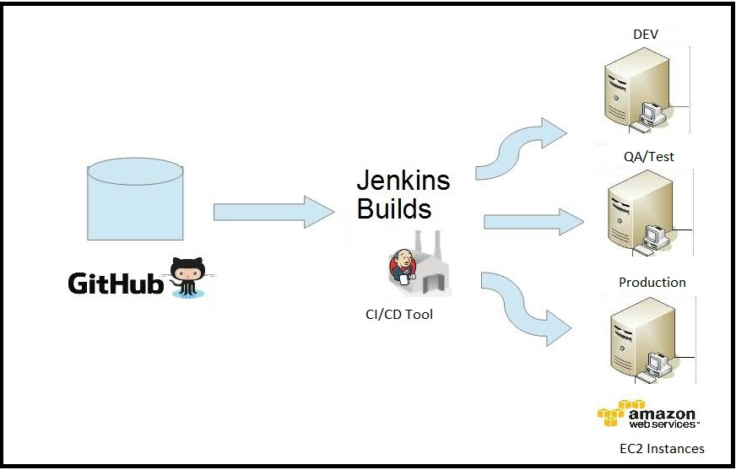

Information
- Github repository, https://github.com/artujose/com.test.app.git
- Jenkins server (private), hosted in http://vmwsco1091.hursley.ibm.com:8080/
- VMs provisioned by a private Cloud Service (Amazon Web Services)

How Jenkins job is setup
Jenkins job will be in charged of:
  - to fetch the source from GitHub repository
  - to build the Java Standalone Application
  - deploy our build output ( .jar file) to our different environments, based on the required task, I will only deploy our jar file to our Production environment ( host name: zeus1.hursley.ibm.com).

SCM (GitHub)
Let's add the GitHub repository where the source lives, also provide the credentials to authenticate to the repository.
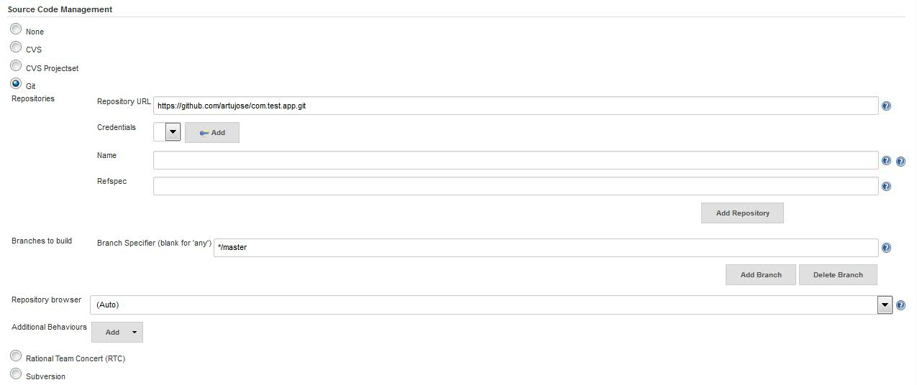

Build section
Let's specify our main Maven pom file, the one which indicates how to build our App.
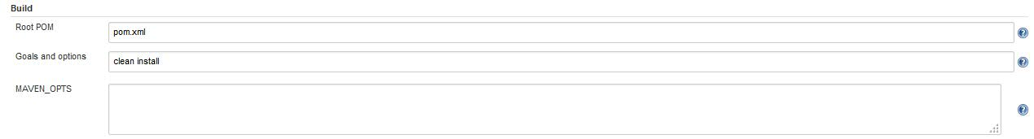
Post Action (Deploy)
For this purpose, deployment process is to send the jar file to a remote server and execute it.
First, let's add this action to have our output attached to the job's output link.

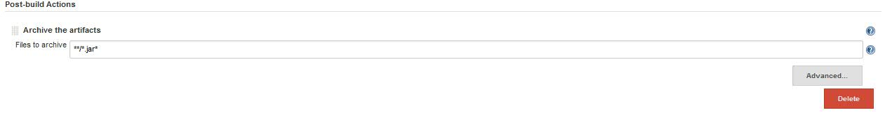
Second, let's add the a “SSH Publisher” entry to send our build output to a remote server (Production VM, provided by a Cloud Service Provider, like Amazon Web Services or it could also be a physical machine), click on “Advanced” button and provide the credentials or use the public/private keys to be authenticated.

Let's specify what are the artifacts we want to send to our remote server, by providing a pattern, give the remote directory to send our artifacts.

Finally add the command to execute our JAVA application (jar file).
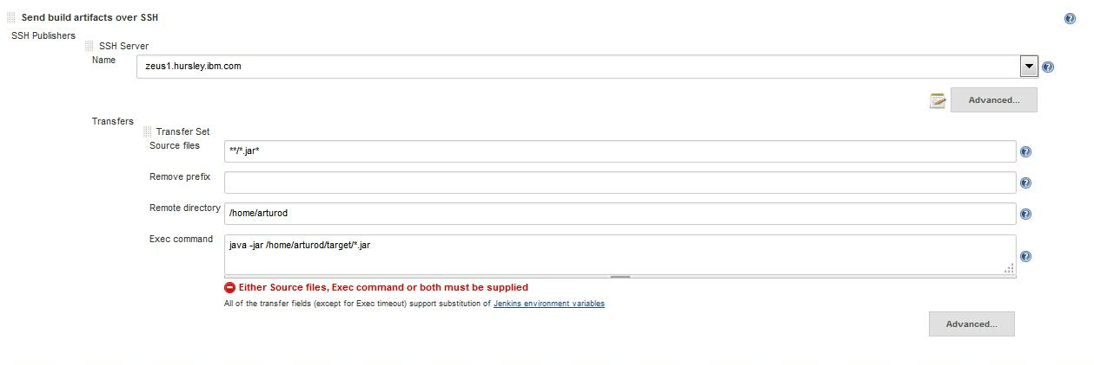
This is how our “build-deploy-test-app” job dashboard looks, see the link (Build Artifacts) to download the artifacts:

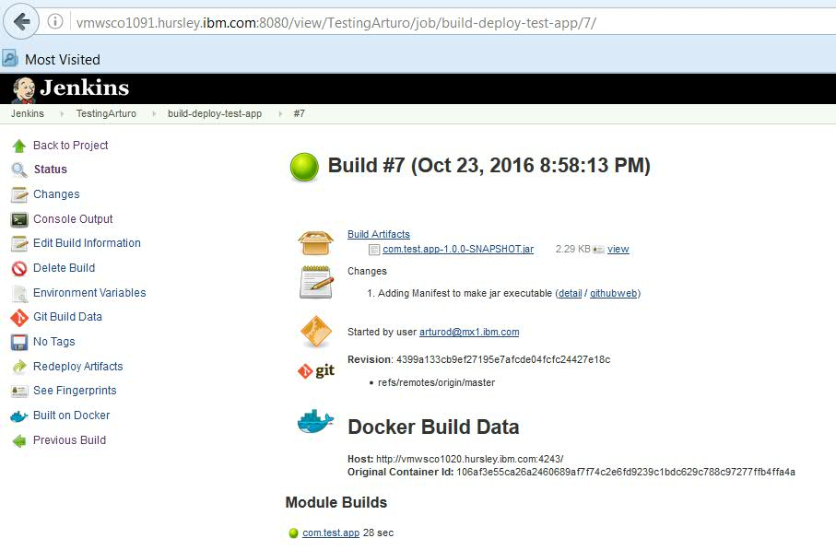
NOTE: Notice I am using a DOCKER container to run this job; I have registered an Image to be used in order to build this kind of Java applications. This image contains the setup needed to run this kind of builds.

From the log file we can see our Java Standalone Application ran perfectly in our remote server.
I have also included the full “Strategy1_jenkins_console_log.txt” file into the package for you analysis.

[INFO] ------------------------------------------------------------------------
[INFO] BUILD SUCCESS
[INFO] ------------------------------------------------------------------------
[INFO] Total time: 8.974 s
[INFO] Finished at: 2016-10-23T20:50:59+00:00
[INFO] Final Memory: 152M/1024M
[INFO] ------------------------------------------------------------------------
Waiting for Jenkins to finish collecting data
[JENKINS] Archiving /home/jenkins/workspace/build-deploy-test-app/pom.xml to com.test/com.test.app/1.0.0-SNAPSHOT/com.test.app-1.0.0-SNAPSHOT.pom
[JENKINS] Archiving /home/jenkins/workspace/build-deploy-test-app/target/com.test.app-1.0.0-SNAPSHOT.jar to com.test/com.test.app/1.0.0-SNAPSHOT/com.test.app-1.0.0-SNAPSHOT.jar
channel stopped
Archiving artifacts
SSH: Connecting from host [488658baac27]
SSH: Connecting with configuration [zeus1.hursley.ibm.com] ...
SSH: EXEC: STDOUT/STDERR from command [java -jar /home/arturod/target/*.jar] ...
My Java Standalone Application is running fine !!!
SSH: EXEC: completed after 401 ms
SSH: Disconnecting configuration [zeus1.hursley.ibm.com] ...
SSH: Transferred 1 file(s)
Started calculate disk usage of build
Finished Calculation of disk usage of build in 0 seconds
Started calculate disk usage of workspace
Finished Calculation of disk usage of workspace in 0 seconds
Finished: SUCCESS

Estimated time to solve this:
2 hrs 30 min

